|  |
| --- |
| CS 524 Introduction to Cloud Computing |
| Dharmit Viradia |
| Lab Assignment 1 |
| Prof. Igor Faynberg |

**Step for Creating an AWS account**

* Signup for AWS Educate for Students

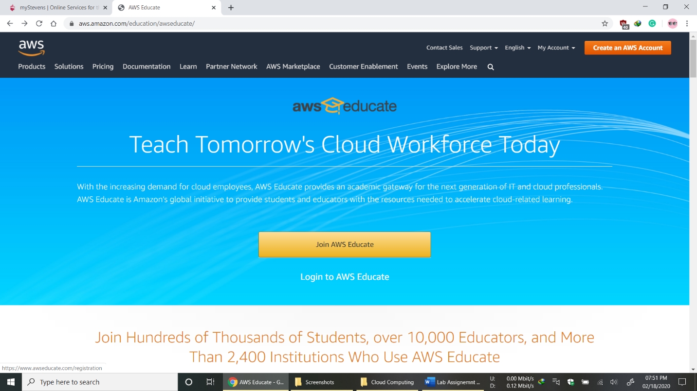

* Choose Role as Student

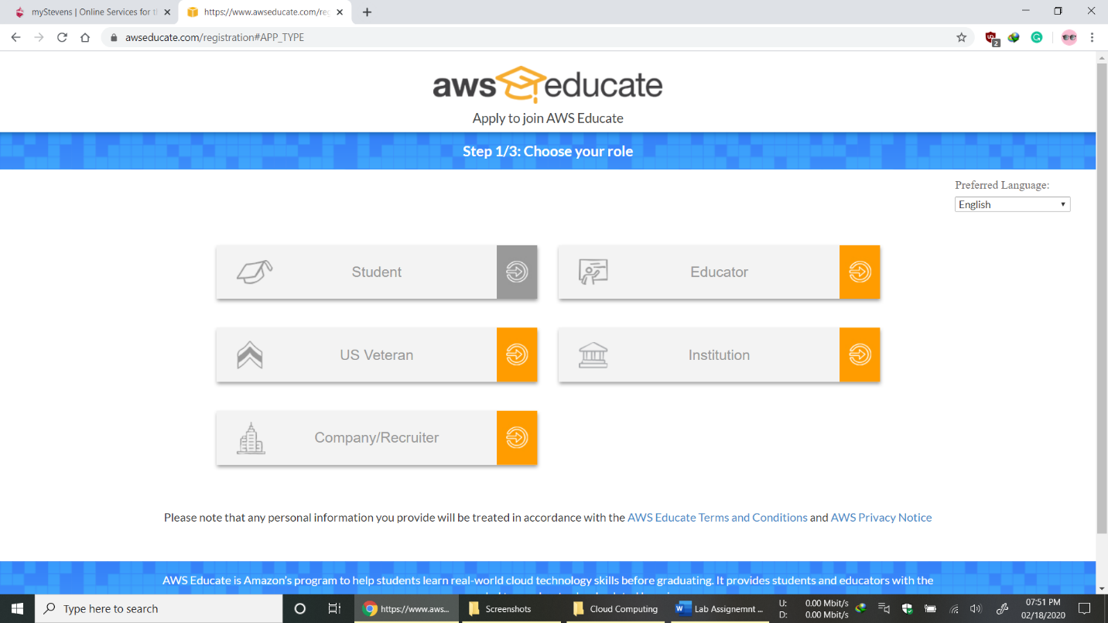

* Fill in Student Details

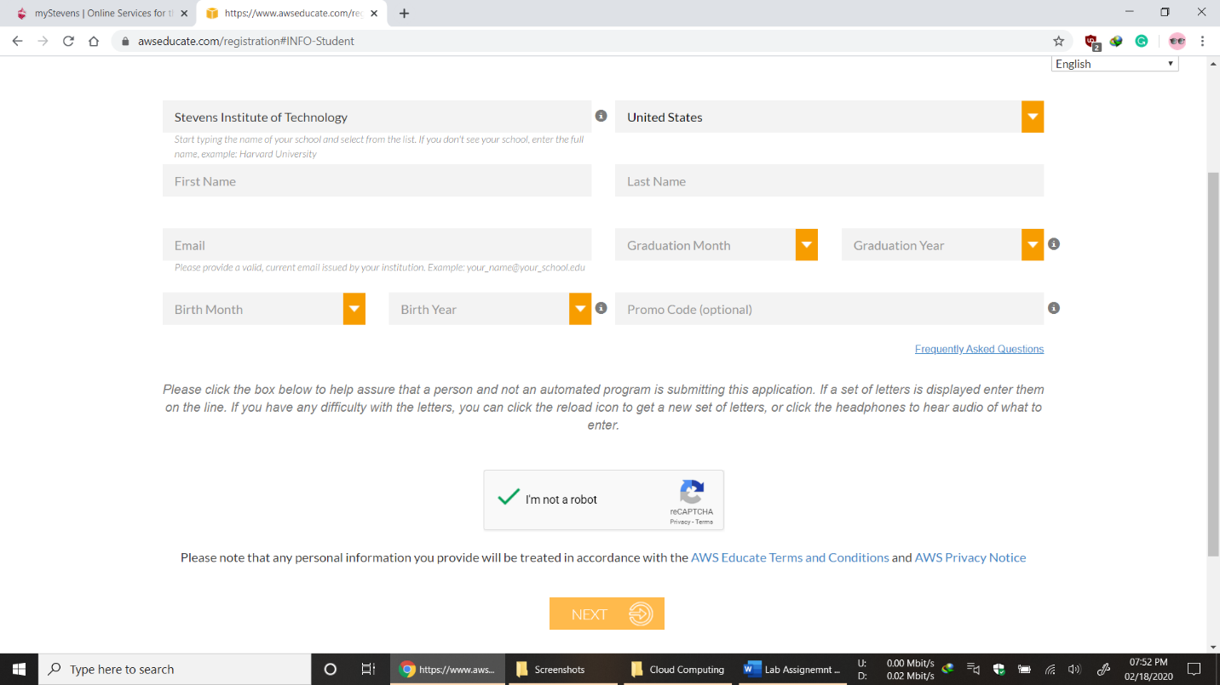

* Agree to terms and condition

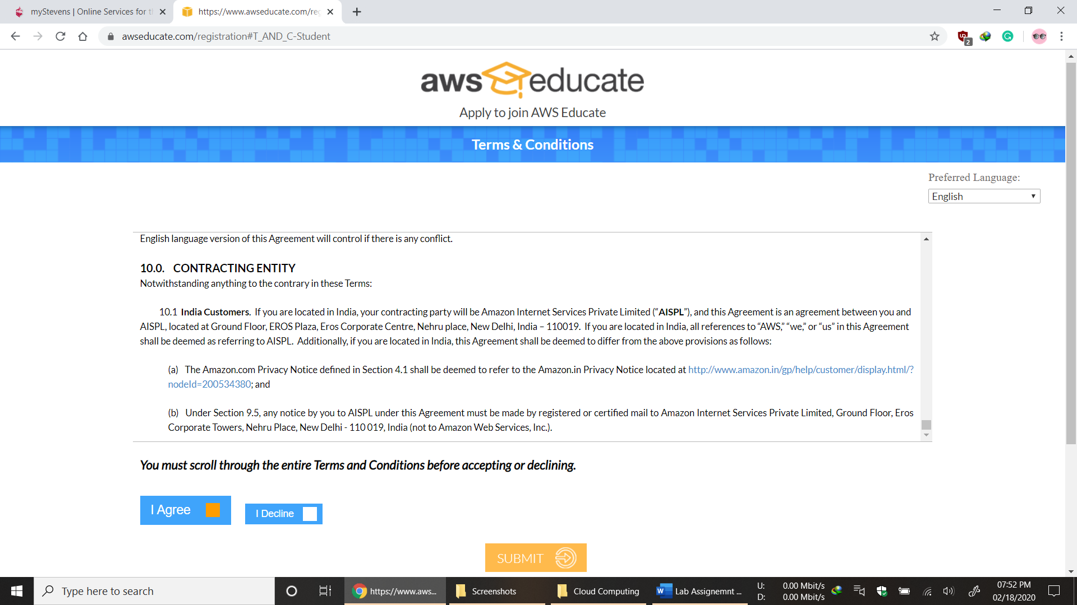

* Verify mail and Set Password

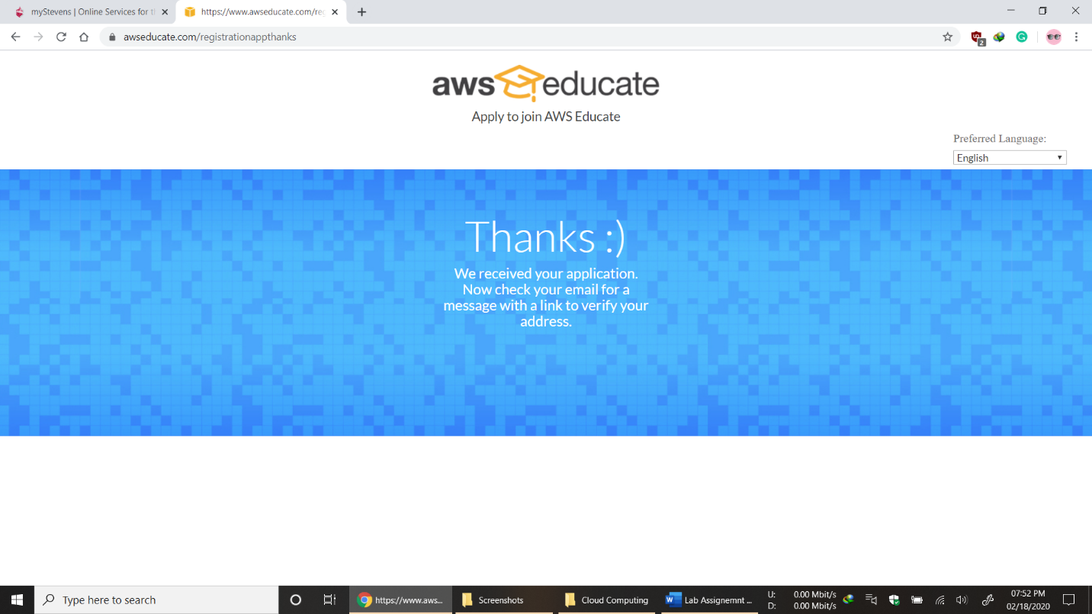

**Step for Creating and Launching AWS instance**

* Login to AWS Educate Account

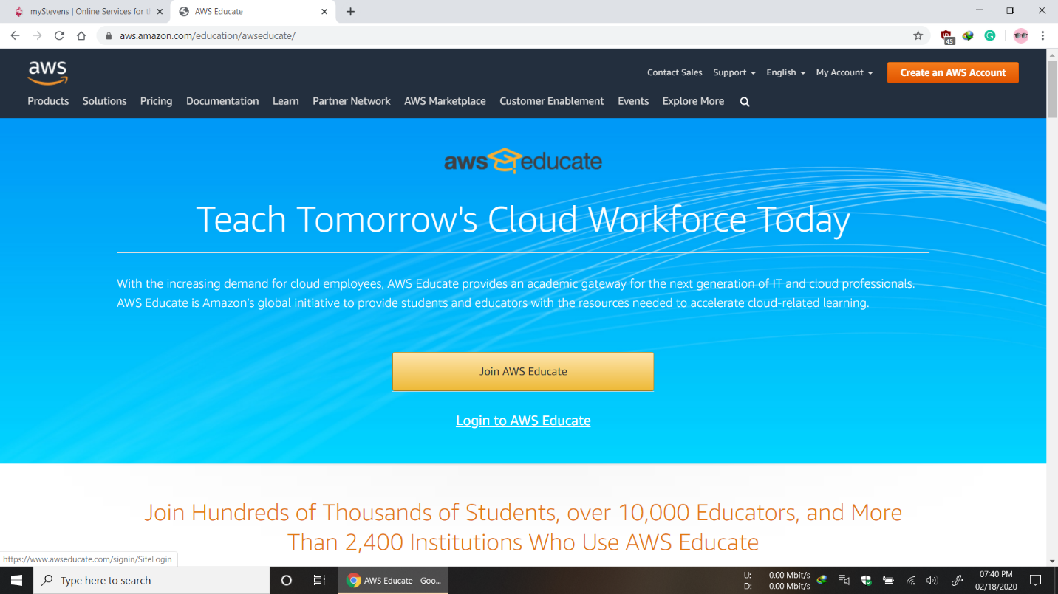

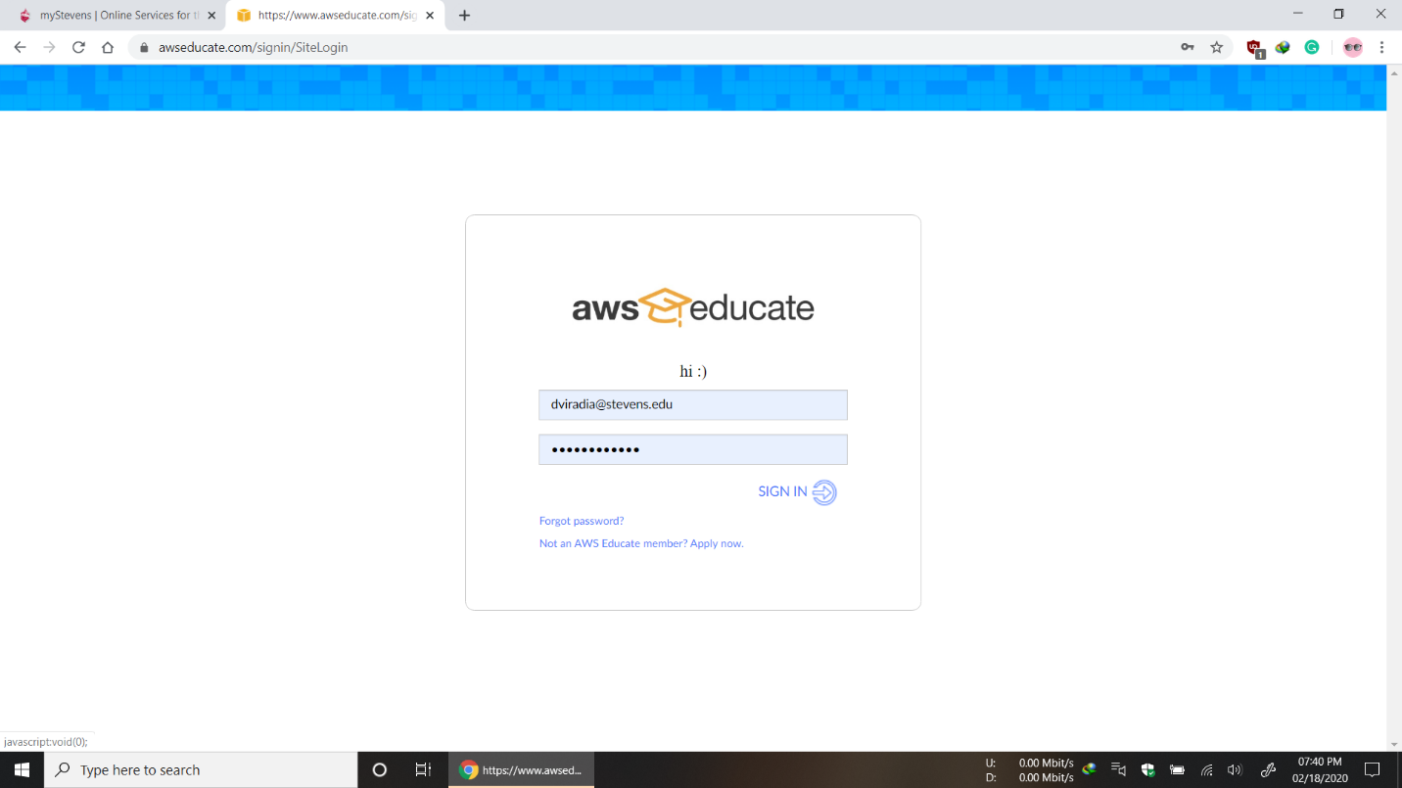

* Go to AWS Account

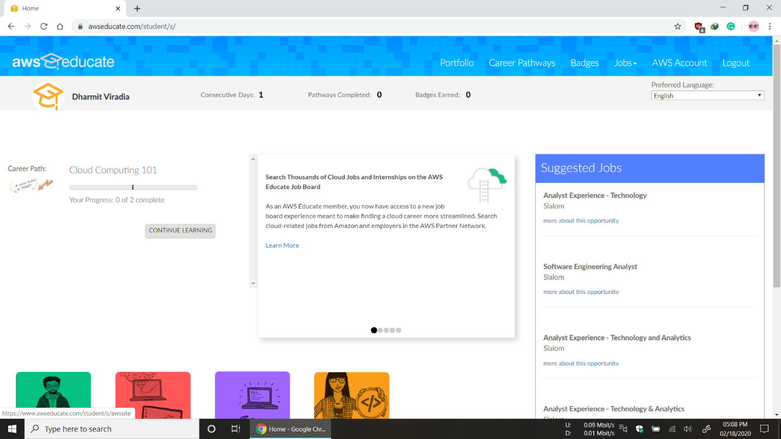

* Launch Virtual Machine

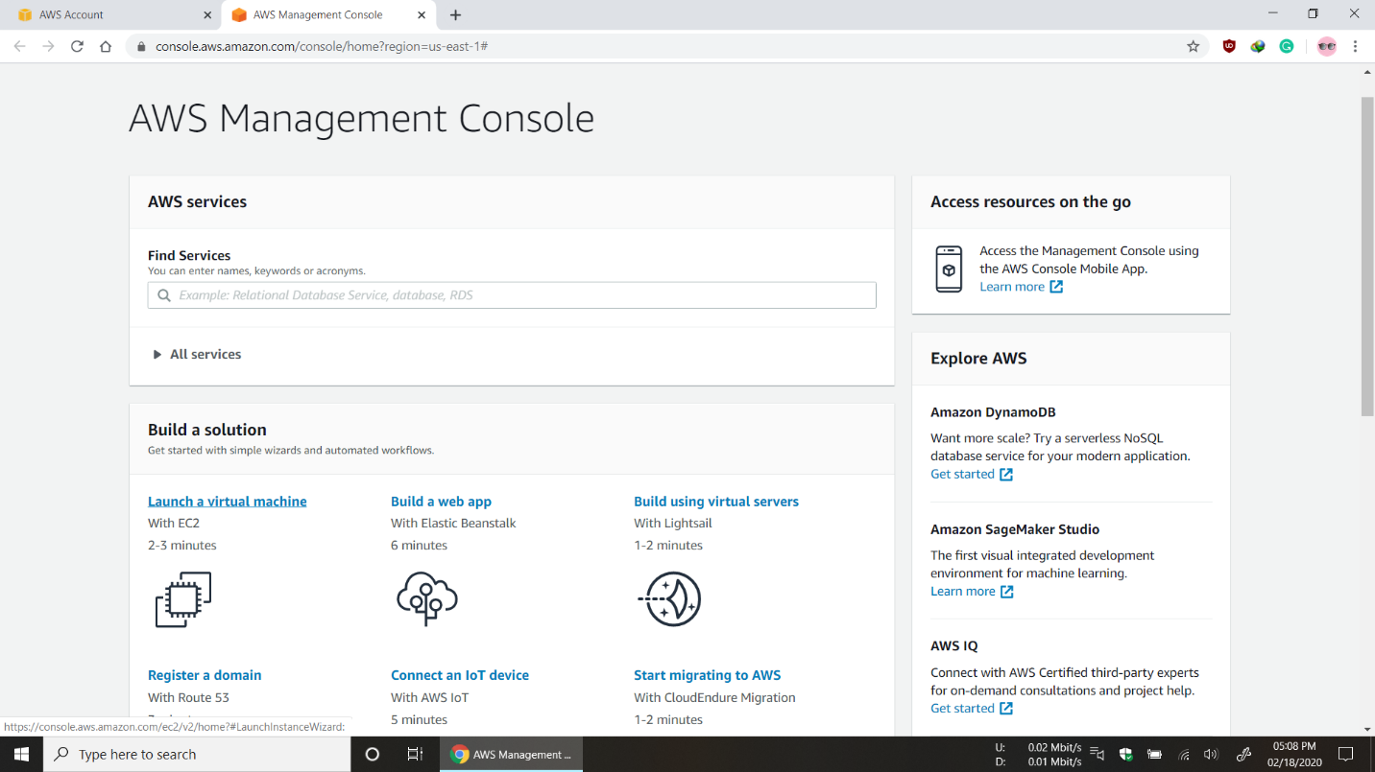

* Select Amazon Linux AMI

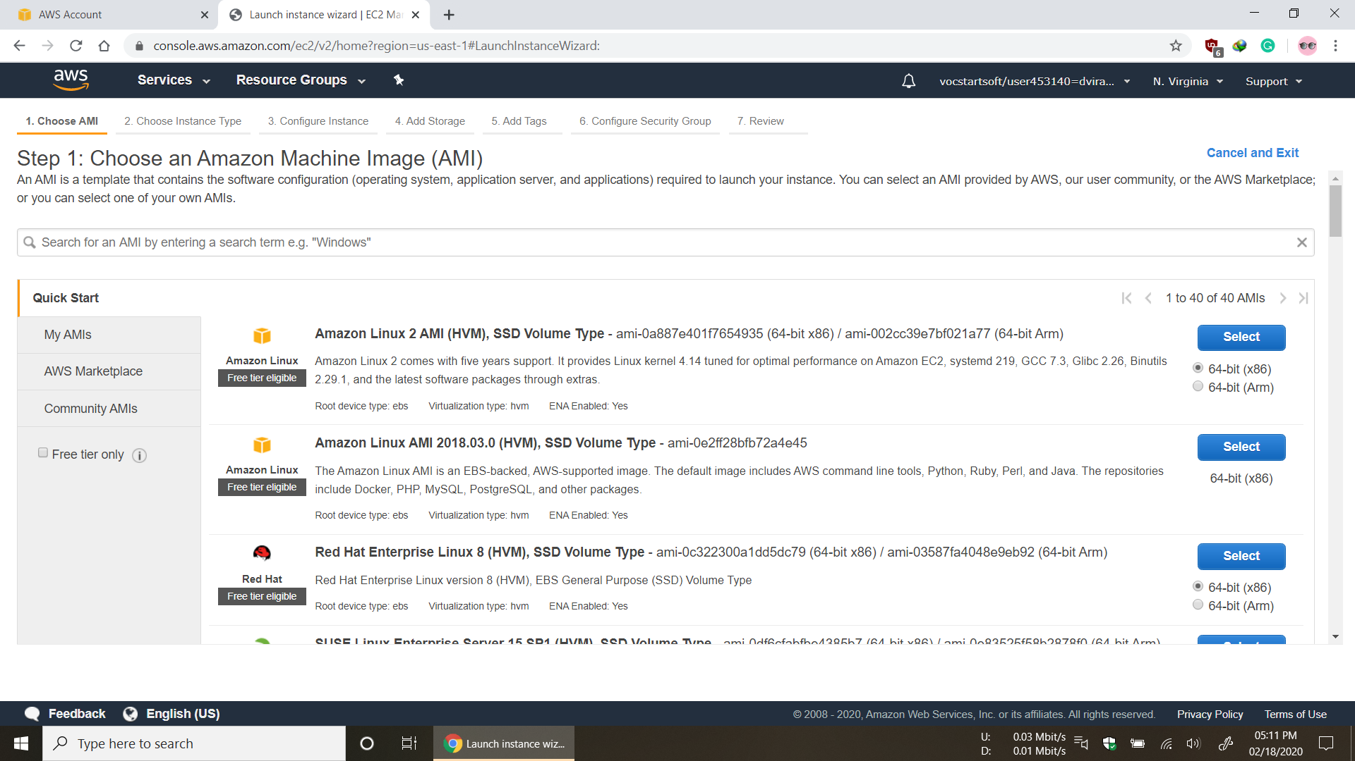

* Select Type t2.micro and review and launch

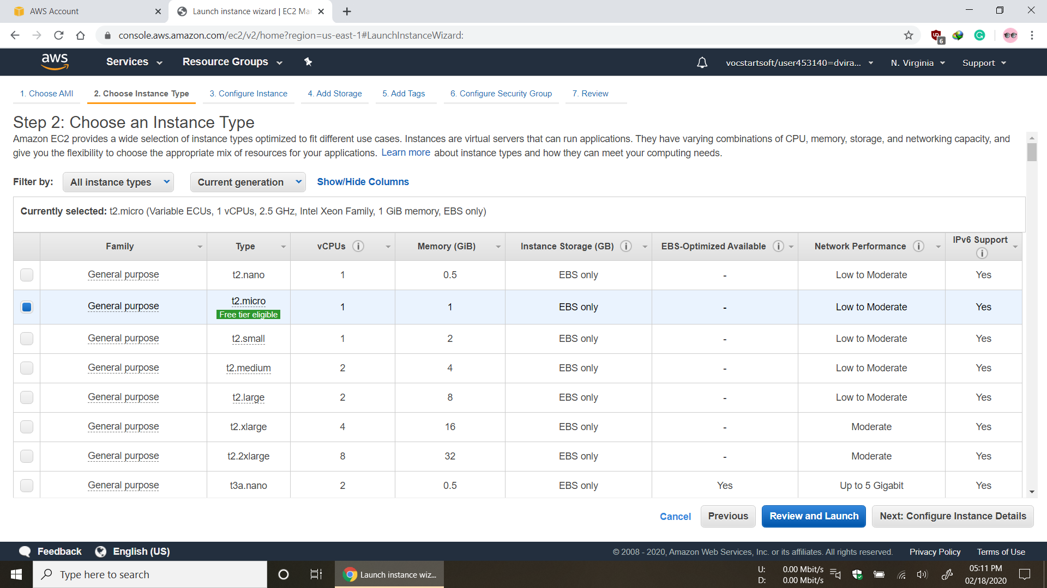

* Launch EC2 Instance

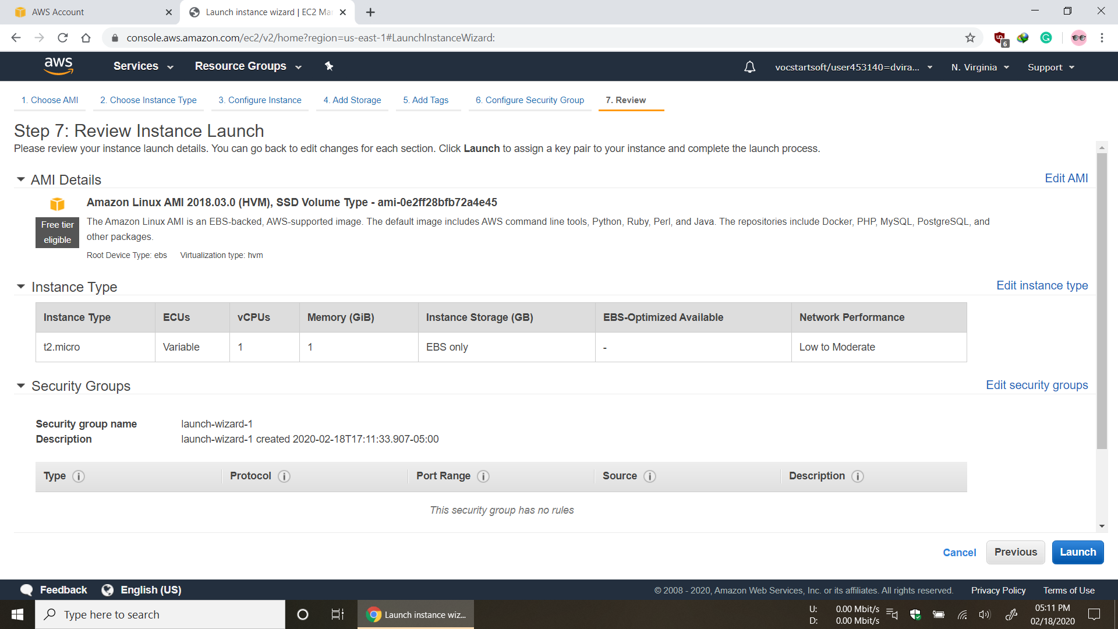

* Create Key Pair

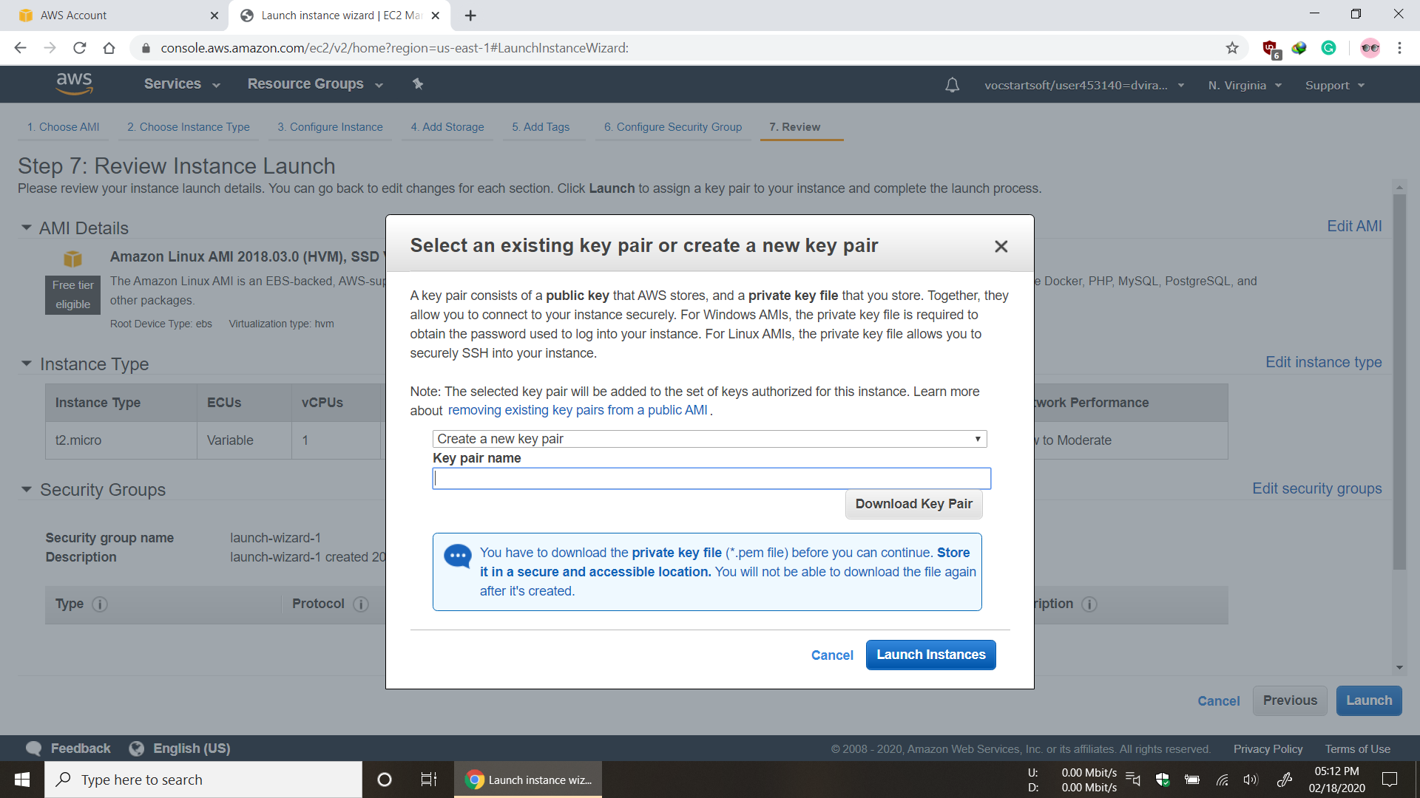

* EC2 Instance is Ready

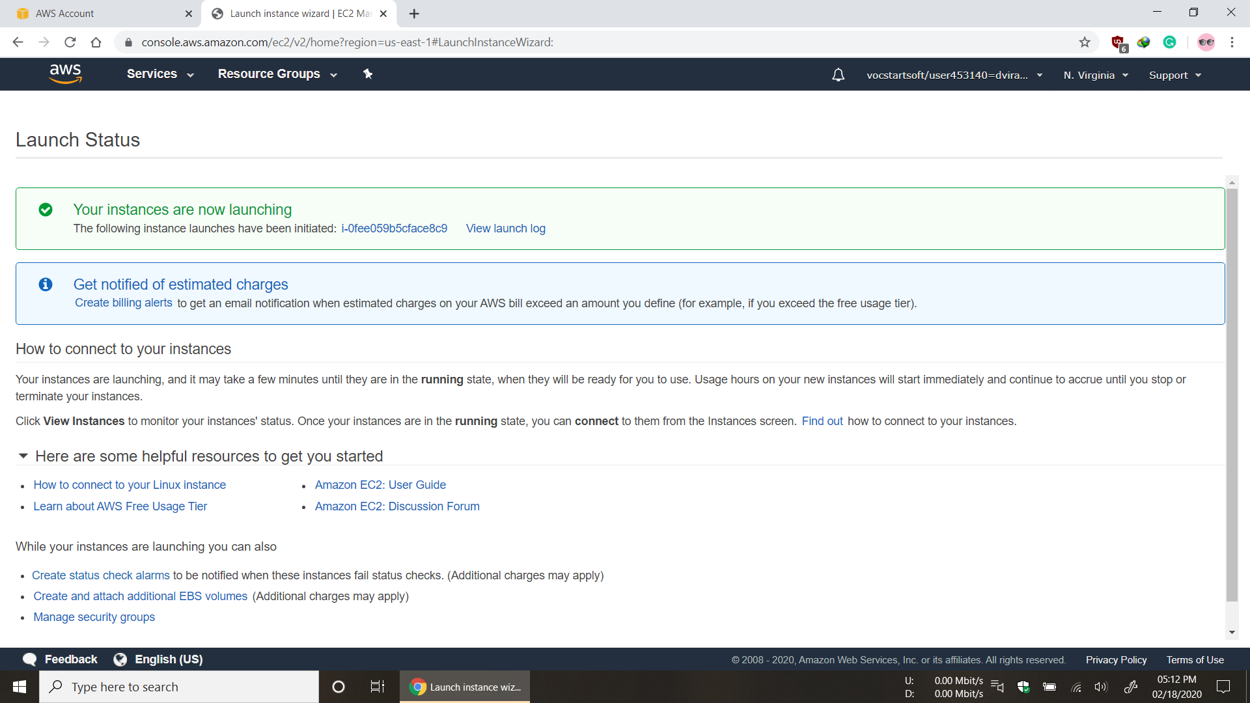

**Step for Accessing AWS instance**

* Establishing connection with EC2 Instance by executing below command using ssh

**ssh -i "key.pem"** [**ec2-user@ec2-54-87-255-14.compute-1.amazonaws.com**](mailto:ec2-user@ec2-54-87-255-14.compute-1.amazonaws.com)

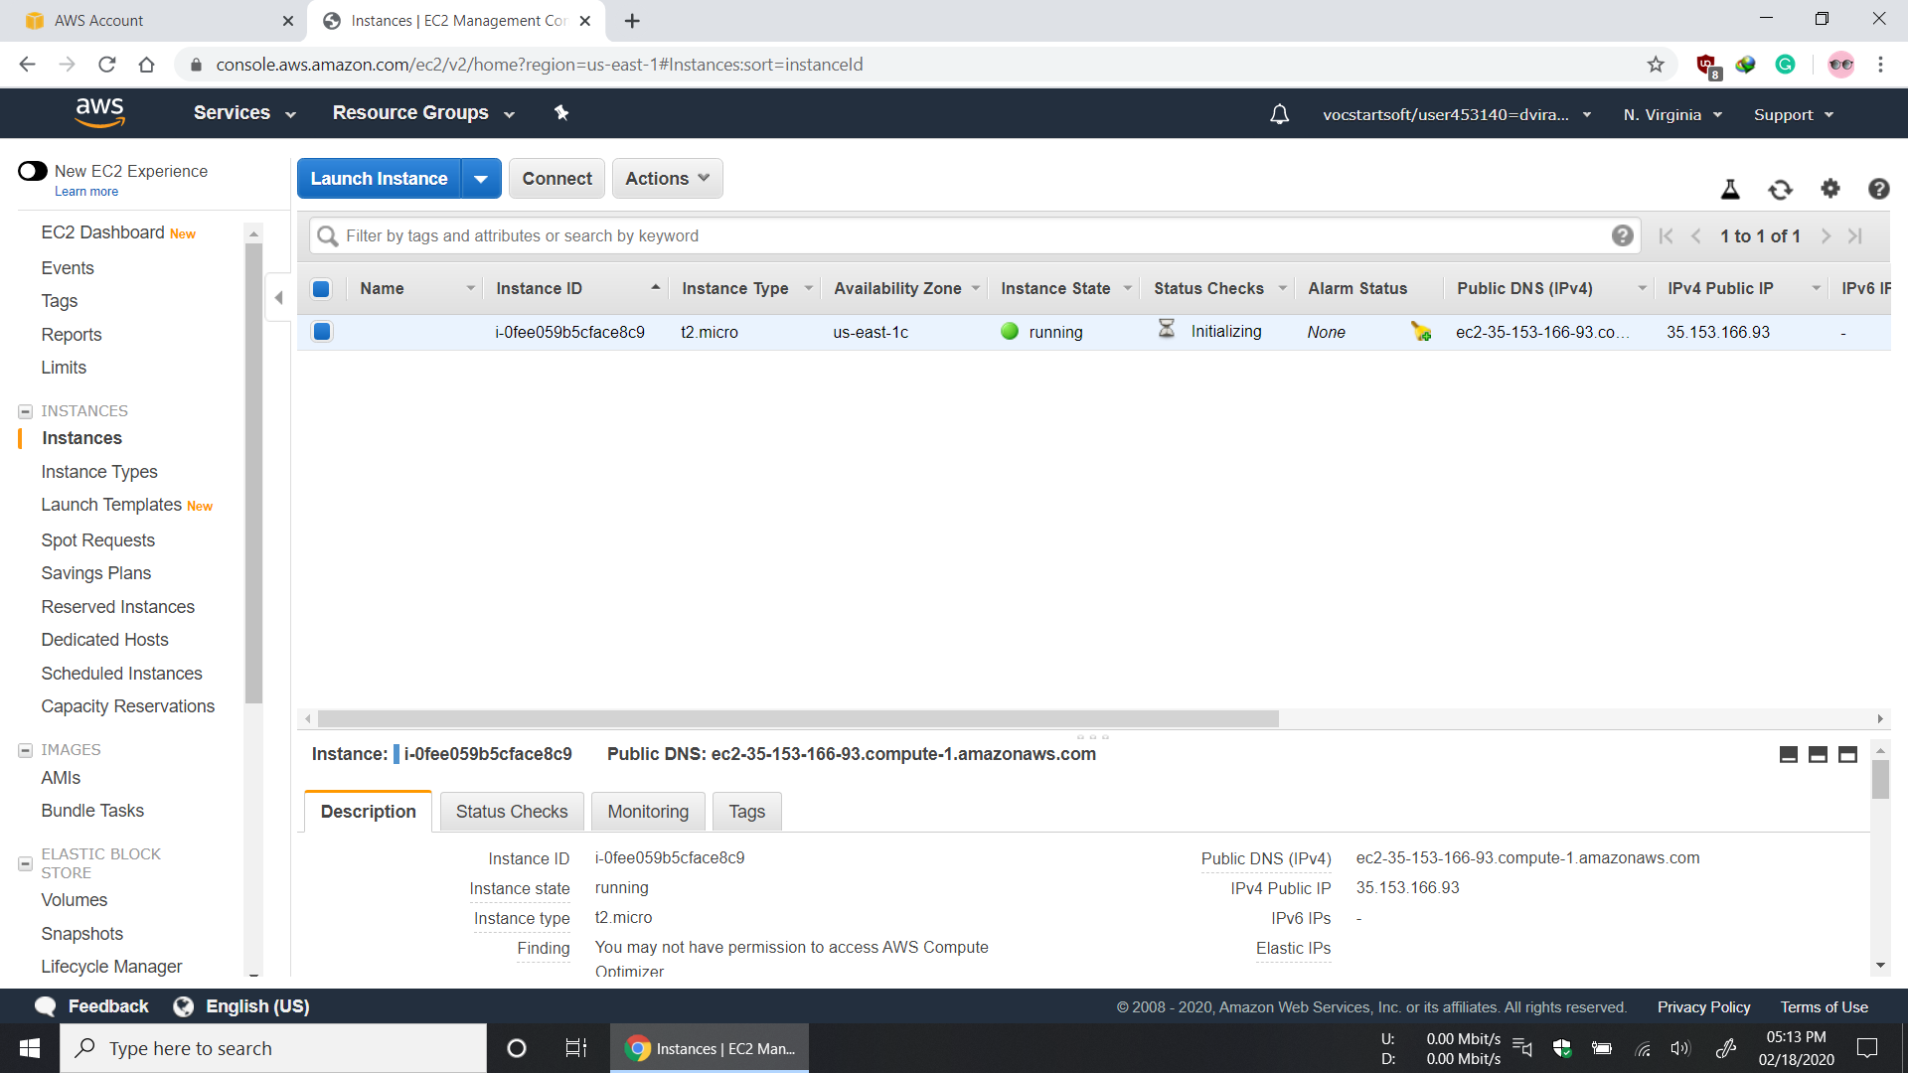

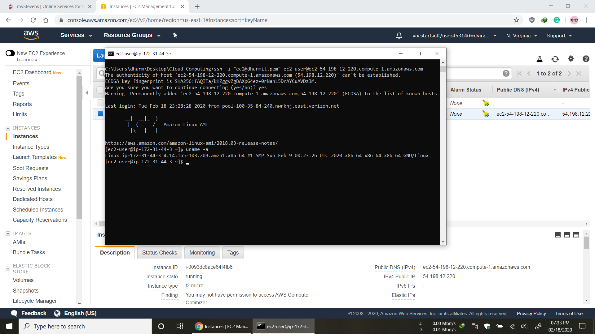

**AWS instance Commands**

* uname –a



Print information about the current system -a prints all information

* whoami

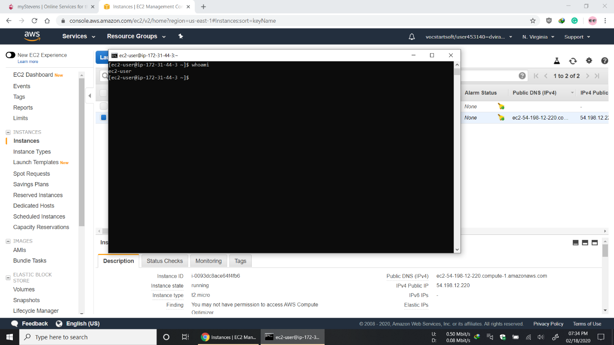

whoami prints the effective user ID

* df -h

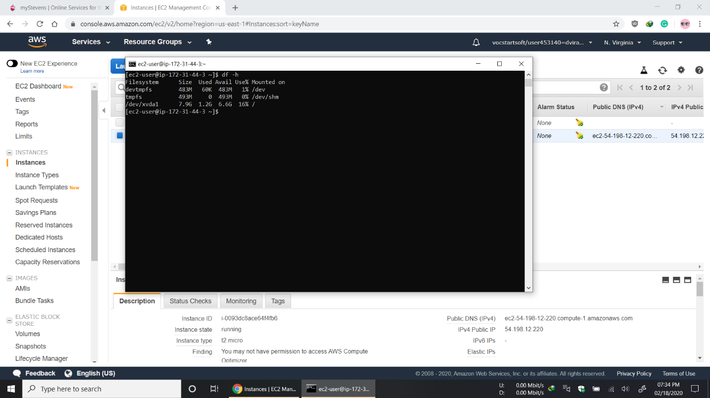

df displays the amount of disk space available on the file system containing each file name argument, -h print sizes in human readable format.

* ifconfig -a

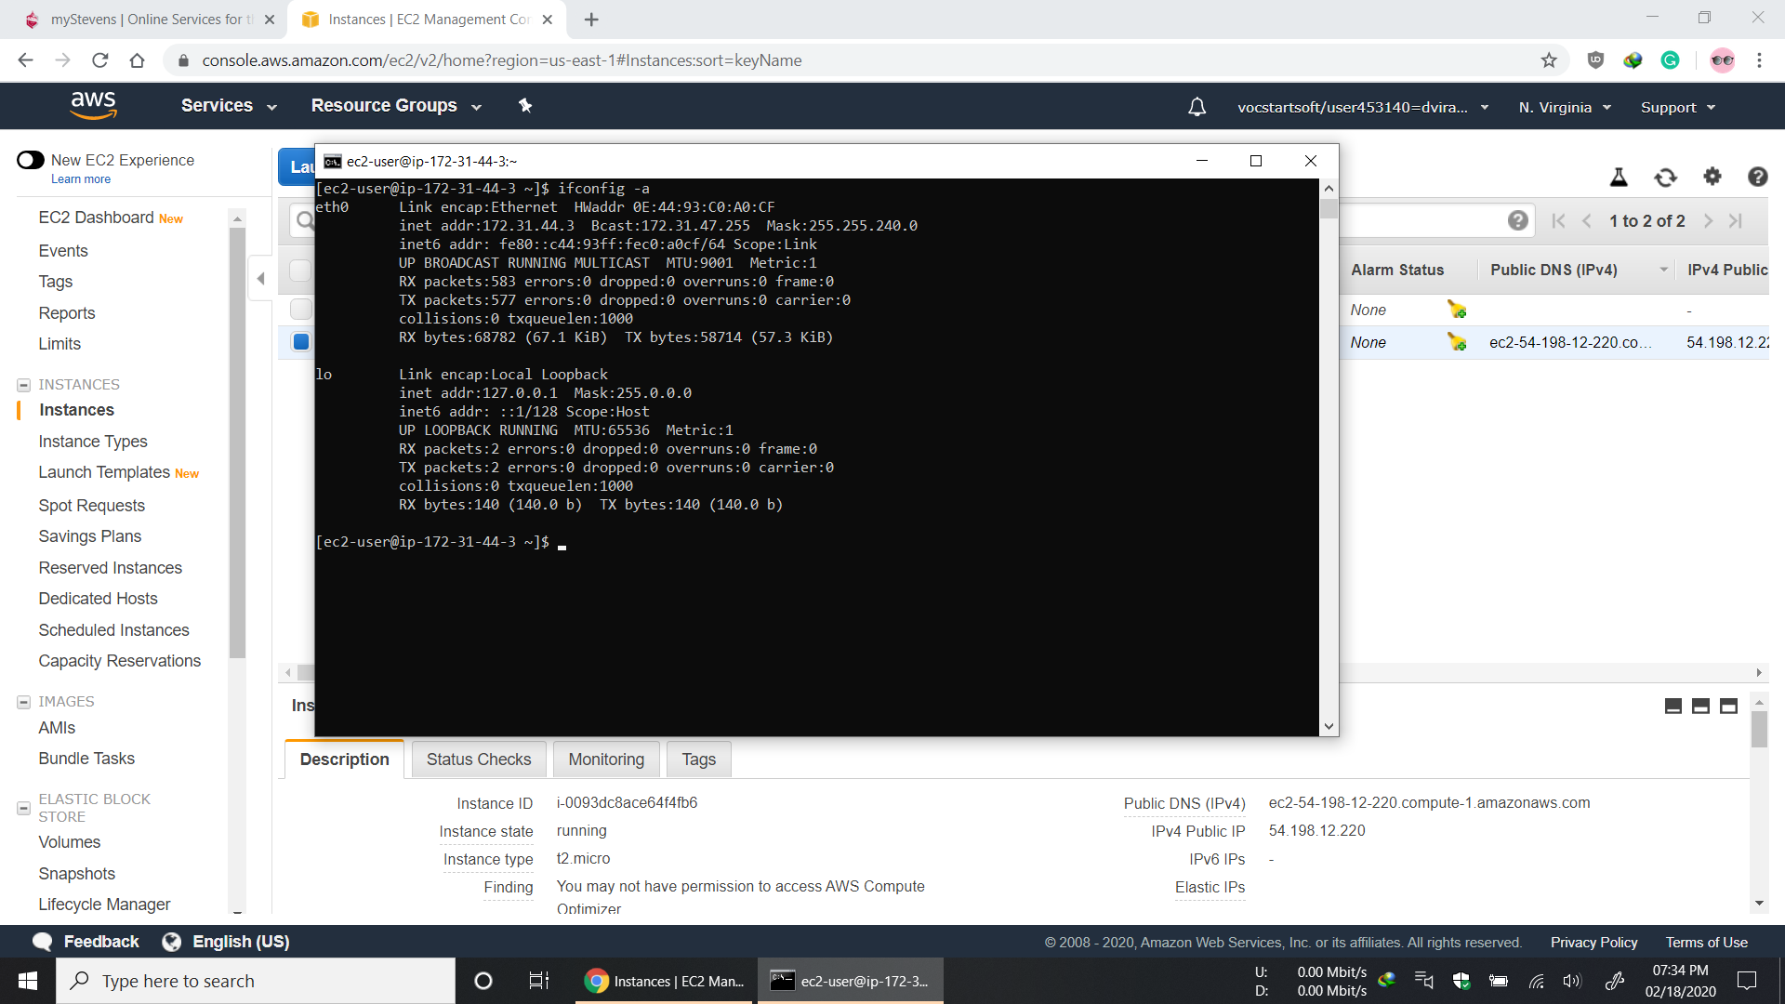

ifconfig –a: it displays the status of all interfaces, even those that are down

* netstat

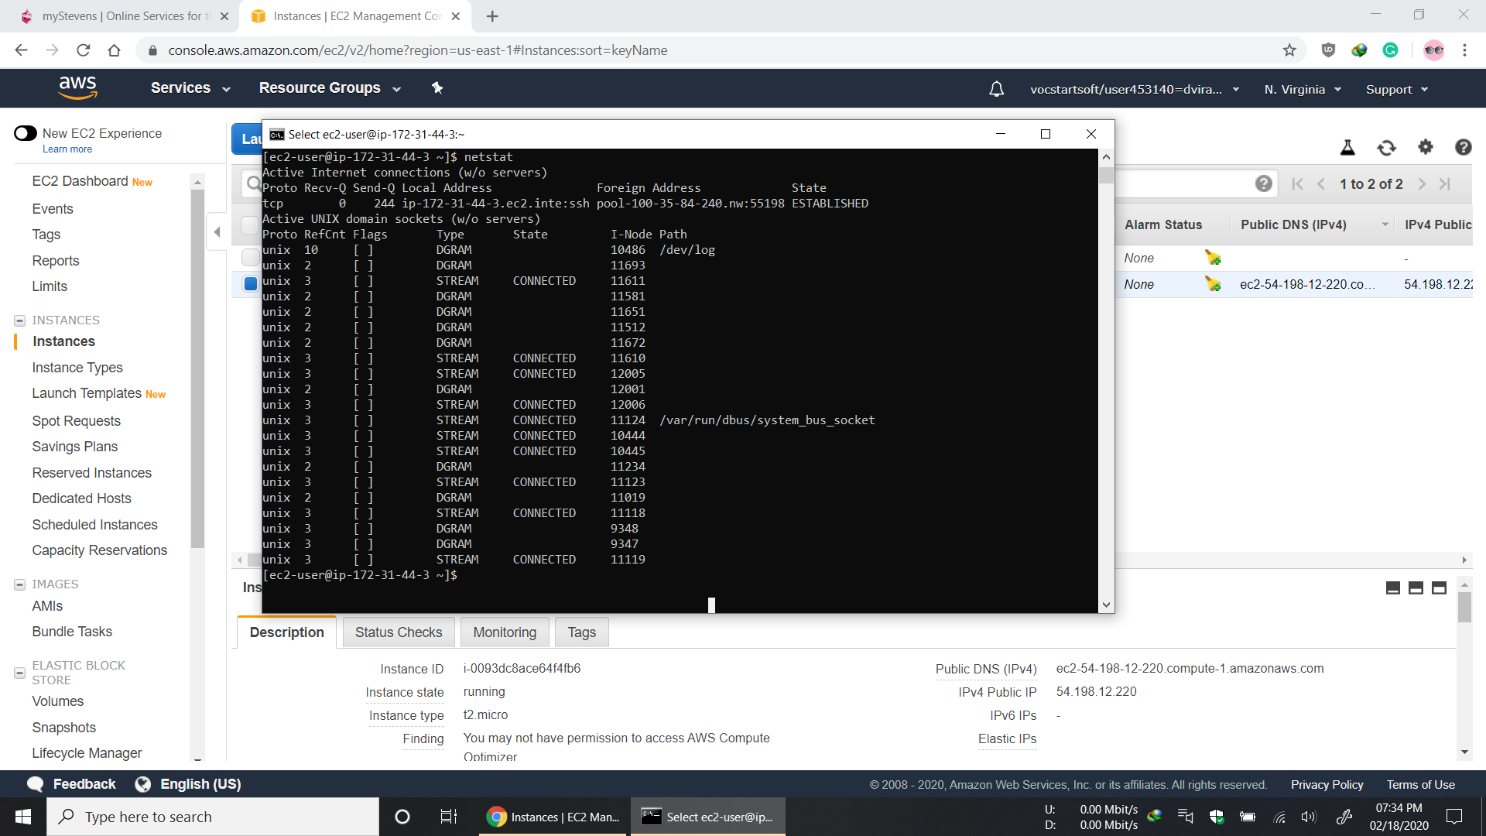

The netstat command is used to print network connections, routing tables, interface statistics, masquerade connections, and multicast memberships.